EXPERIMENT 2
Execute and display the results for the following commands in Kali Linux Operating Systems:
tree command
head command
tail command
AIM : To execute and study the tree, head, and tail commands in Kali Linux and observe their results.
DESCRIPTIONS
1. tree Command : The tree command is used to display files and directories in a tree-like hierarchical structure.
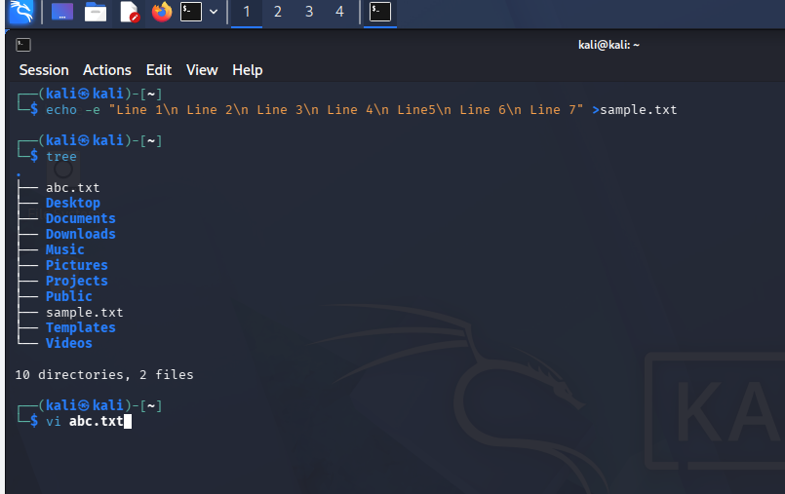
2. head Command : The head command is used to display the beginning of a file. By default, it displays the first 10 lines.
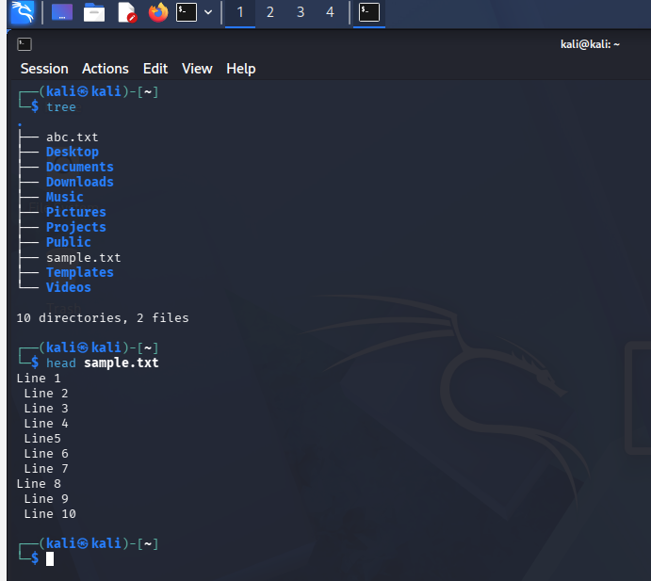
3. tail Command : The tail command is used to display the end of a file. By default, it displays the last 10 lines.
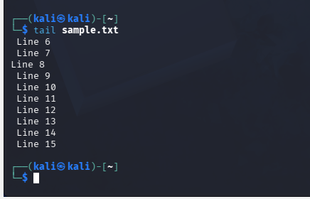
RESULT : The tree, head, and tail commands were successfully executed in Kali Linux. The tree command displayed the directory hierarchy, while head and tail displayed the beginning and end portions of a text file respectively.

